Create a file with extension(/home/demo.txt)

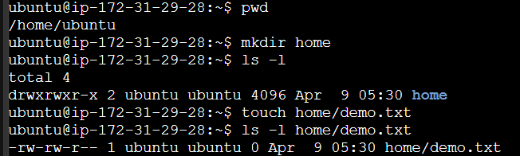

Change the permission set of that file so that any user can read it, group can read n write and owner read/write/execute it.

